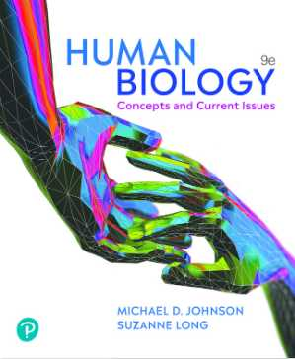
Textook for the course
Required reading: ISBN: 9780137958559 - Mastering Biology* access code w/ eText for
Johnson, Human Biology, 9e (18 week custom access); available online from the Valencia Bookstore.
You will also have the option to purchase the
textbook if so desired.

